Universal support from EYFS – Year 6
In order for all children to flourish, and are equipped, resourced and empowered to see their future through eyes full of hope, each child is treated with dignity and respect for they are of unique and inherent worth. This whole school provision is an overview of intervention which may be accessed over the whole year by each year group. Using The Graduated Approach of Assess < Plan < Do < Review, children would access an intervention, or a small number of interventions linked to an identified need for a time limited period, The number of children and the intervention provided will change each term depending on the review cycle. Pupil voice is routinely sought and used to inform in planning for adaptions and interventions so that each individual child knows that they are loved unconditionally, enabled ambitiously, supported compassionately and championed relentlessly.
Adaptive Teaching linked to the Kent Mainstream Core Standards in place across the school. Use of additional adult is planned to maximise their impact on learning and to develop the skills required for independence.
Communication & Interaction | Cognition & Learning | Social, Emotion & Mental Health | Sensory & Physical
- Use of NELI on line screening assessment and resources  - Use of Speech Link on line assessments and resources  - Visual Timetables are used effectively with events ticked off or taken off when finished  - Topic and core vocabulary displayed with pictures/symbols  - Pre teaching/overlearning of topic vocabulary with small group when required  - Pupil self- evaluation and self -assessments  - Awareness of optimum seating arrangements reflected to needs  - Clear concise instructions and supports with visual and non-verbal cues when needed.  - Simplified language/ break down language into chunks  - Task management boards to break down tasks into smaller chunks  - Awareness and use of 10 sec rule to support slower processing  - Open question technique to challenge all pupils  - Use of alternative recording methods: mind maps/ICT programmes/ sentence sequencers.  - Use of ICT and software  - Planned transition programmes to support all pupils to transition from nursery to school, within school and KS2 to KS3 | - Daily phonics through Read Write Inc (EYFS, KS1)  - Daily spellings through Spelling Shed  - Number songs & action (EYFS, KS1)  - Whole school approach to maths – White Rose curriculum & use of manipulatives  - Whole school reading approaches – Readerful & Schofield & Sims  - Inviting books areas in the classrooms and around the school  - Library time  - Daily story time in EYFS & KS1  - Writing plans, templates and scaffolds  - Talk to your partner & thinking time  - Visual clues/symbols/gestures  - Brain breaks to include music and dance to stimulate thinking and learning  - Modelling is used to aid understanding  - Use of indoor & outdoor environments  - Interactive whiteboards are used to promote engagement and to scaffold lessons  - Homework is adapted to meet each individual child’s need. | - Whole school behaviour policy  - Whole school reward system - dojos  - Support for positive behaviour - Restorative practice  - presenting behaviour  - Colour Monsters & 5 point scale to support behaviours & emotions  - Use of buddies  - Visual timetables  - Social stories  - Transitions are planned and prepared for  - Access to inclusion base Starfish | - Disabled toilets in both the main school and Community Building  - Health Care Plans for medical needs  - Medical room  - Accessibility plan reviewed annually  - Access to water in lessons  - A range of writing tools/access equipment available: pencil grips, wishbone pencils, writing slopes, left/right/loop scissors  - Kickbands  - Wobble cushion  - Weighted blankets  - Ear defenders  - Different coloured paper and fonts are used for reading  - Access/special arrangements for internal/external learning assessments where needs identified/evidenced  - After school clubs and trips fully include children with SEND  - Displays are meaningful and visually accessible to reduce sensory overload  - Sensory stimuli is reduced as and when needed  - Inclusion base provision - Starfish

Additional Targeted Support
Some learners with SEND will require more support than most of their peers. As a school we understand that children flourish at different times and speeds. This support will be provided in addition to the whole school provision. When a child is accessing this additional support, they will have an identified or will be presenting with characteristics of an identified special educational need or disability which will fall under one of the four board areas of need set out in the SEND code of practice 2015. The Graduated Approach is used to evaluate provision and to inform next steps. Our school community understands the concept of Ubuntu – sharing the highs, lows, joy and pain, twists and turns, celebrating each other in order for everyone to flourish.
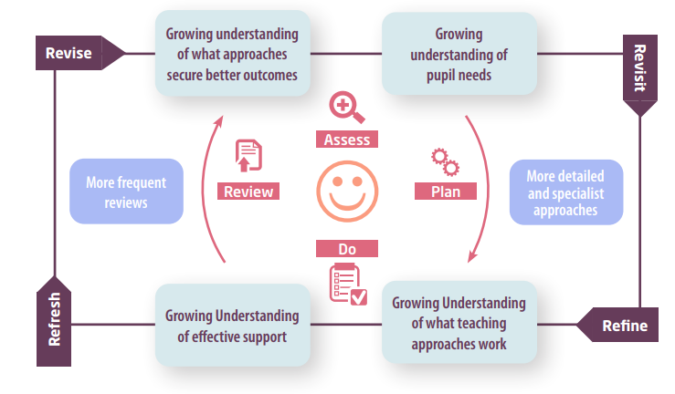
Communication & Interaction (Includes ASD) | Cognition & Learning | Social, Emotion & Mental Health | Sensory & Physical
- All staff trained in Autism Awareness training  - A multisensory approach to learning  - Visual support  - Communication support with use of visuals or objects of reference  - Makaton  - Language link groups  - Speech Link interventions  - Cued articulation  - Language programs devised by SALT link therapist  - Introduce language through rhyme & song  - Social stories/comic books  - Now and next boards, sequence strips  - Nurture groups  - Social rules displayed visually and referred to explicitly.  - Help/exit cards  - Alternative methods for communicating e.g white boards, visual aids, signals or symbols | - Additional support with phonics  - BRP  - Use of work stations  - Creative writing supports: writing frames, story boards  - Timers to structure tasks  - Learning breaks  - Explicit teaching of inference  - Teach touch typing  - Provide alternative methods of recording  - Differentiated resources to meet the child where they are at  - Provision of a scribe  - Activities to support memory  - Clicker program used to support writing | - Allocation of key person  - Lunch/break time clubs  - ‘Buddy system’  - Nurture groups  - Mindfulness tasks  - Routines and changes communicated in advance  - Boxall profiling and follow up tasks  - ABC charts  - Risk assessments in place if needed  - Safe places available  - Backward chaining | - Sensory toolbox  - Sensory circuits  - Planned transitions times earlier/later  - Pre warning of fire drills  - Fizzy & clever hands

Specialised Individual support
The school takes a long term view of each child’s development, supporting, prioritising and celebrating the family. The school is well supported by a high range of integrated professional services to attend to complex individual needs e.g STLS, SALT & The Beacon, to develop well planned curriculum pathways.
For EHCP Plans: These will be reviewed alongside families and children with the child’s Personalised Learning Plan at least three times a year. The EHCP plan will be reviewed annually as per the review documents on KELSI.
For High Level Need pupils: Personalised learning plans will be reviewed during parent’s evenings
For Behaviour Plan pupils: Personalised behaviour plans will be reviewed termly with the Class teacher.

